
Humberside Fire and Rescue Service
Council Tax Precept Consultation

For the next financial year in 2026/27, we are asking members of the public if they would be willing to increase their funding for their fire and rescue service.

The government is changing how grants are allocated nationally through the Fair Funding Review. From 2026/27, a new Local Government Fair Funding Formula will apply. This could mean the Service has less funding and may need to make savings over the next three years.

Even if the government’s assumption of a £5 annual increase happens (based on a Band D property) our budget could still reduce by up to £3 million, which is around 5% of our budget. Without that increase, the reduction could be as much as £5 million. These changes may require us to review how fire and rescue services are provided in the community.

Local decisions on the Council Tax precept help us prepare for these changes. We recognise that any change to Council Tax impacts households. For context, many homes in the Humber region are in lower Council Tax bands, so any change would depend on your property band.
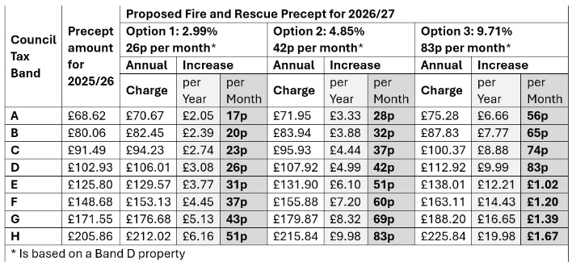
Take Part Here

We are asking for your support by selecting one out of the four options below:

Option 1: 2.99% increase – approx 26p/month (£3.08/year) on a Band D property
Option 2: 4.85% increase – approx 42p/month (£4.99/year) on a Band D property
Option 3: 9.71% increase – approx 83p/month (£9.99/year) on a Band D property (requires referendum, adding costs)
Option 4: No increase

Consultation closes at 5pm on Friday 30 January 2026. The final precept recommendation will be considered by Humberside Fire Authority at its meeting on 13 February 2026. If you have any questions about the consultation or require it in an alternative format, please email: corporatecommunication@humbersidefire.gov.uk

Return to: corporatecommunication@humbersidefire.gov.uk
Humberside Fire and Rescue Service HQ, Summergroves Way, Hull, HU4 7BB

About you

We want to make sure that we are getting responses from our communities across the Humber region and to help us to ensure that we are achieving this, please tell us about yourself.
How did you discover the consultation survey? (Please tick all that apply)

Humberside Fire and Rescue Website |  | Social media
Member of staff – face to face |  | Local press
My Community Alert |  | Staff Newsletter

Do you work for Humberside Fire and Rescue Service?

Yes |  | No
Which county do you live in?

Hull |  | East Riding
North Lincolnshire |  | North East Lincolnshire
I live outside of the Humber region |  | If so, please state:
Do you consider yourself to have a disability?

Yes |  | No
What age are you?

Under 18 |  | 35 - 44
18 - 24 |  | 45 - 54
25 - 34 |  | 55 - 64
65+ |  | Prefer not to say
What gender do you identify as?

Man |  | Woman
Non-binary |  | Transgender
Prefer not to say |  | Other

What ethnicity are you?

Asian or Asian British - Bangladeshi |  | Asian or Asian British - Indian
Asian or Asian British - Pakistani |  | Asian British – Other Asian Background
Black or Black British - African |  | Black or Black British - Caribbean
Black or Black British – Other Black Background |  | Chinese
Mixed – Other Dual Heritage |  | Mixed – White and Asian
Mixed – White and Black African |  | Mixed – White and Black Caribbean
White - British |  | White - Irish
White - Other |  | Prefer not to say

