Freedom of Information - Humberside Fire and Rescue Service
2026/27 048 Abandoned Building Fires

The request is:
For each of the past five financial years (2021/22 to 2025/26, or the nearest equivalent reporting period), please provide:
- The number of fire incidents attended involving buildings recorded as:
  - derelict;
  - disused;
  - long-term vacant;
  - abandoned; or
  - any equivalent category used by your service.
- Of those incidents, please provide (where recorded):
a) The number that resulted in fatalities.
b) The number that resulted in non-fatal casualties.
c) The number that were recorded as deliberate fires (arson).
- If your service records the primary property type for these incidents, please provide a breakdown between:
  - Residential buildings
  - Commercial/industrial buildings
  - Other buildings
- If your service does not use the terminology above, please provide the closest equivalent classification and explain how those incidents are recorded.

The response is:

Please see the responses below.

1. The number of incidents in building deemed vacant.

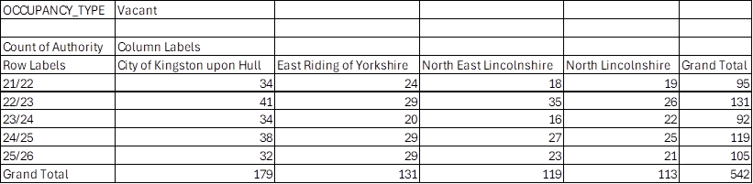

2a and b.
None recorded

2c. The number of vacant properties separated into accidental and deliberate.

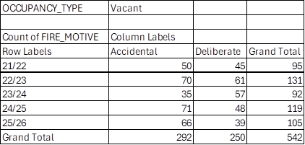

3.Property type separated by Commercial, Domestic dwellings and Other.

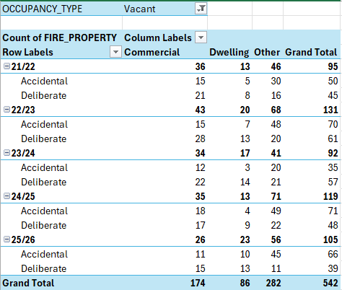

If you are unhappy with the handling of your request, you have the right to ask for an internal review. A request for an internal review should be made within 40 working days of the date of this email. If you are not happy with the outcome of the internal review, you have the right to apply direct to the Information Commissioner at www.ico.org.uk/foicomplaints. The postal address is: Information Commissioner’s Office, Wycliffe House, Water Lane, Wilmslow, Cheshire SK9 5AF.

