Freedom of Information - Humberside Fire and Rescue Service
2026/27 029 St Andrews Quay Retail Park

The request is:
Do you hold any records pertaining to the storage of petroleum at this site.

A red line boundary for the site is shared below.

Any information would be greatly appreciated.

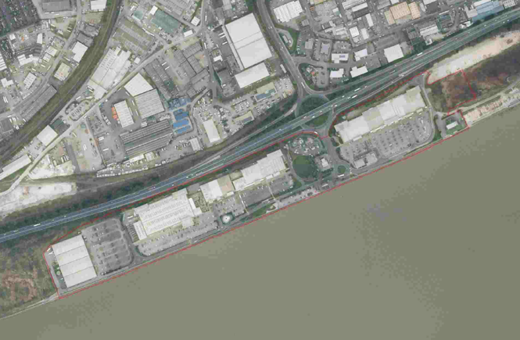

The response is:

Humberside Fire & Rescue Service do not hold any information or records relating to the storage of petroleum in the areas detailed within the initial request. Whilst there is a petrol station located within the aforementioned area, all petroleum licensing and on-going management and control within the area is facilitated by their respective council licensing teams.

If you are unhappy with the handling of your request, you have the right to ask for an internal review. A request for an internal review should be made within 40 working days of the date of this email. If you are not happy with the outcome of the internal review, you have the right to apply direct to the Information Commissioner at www.ico.org.uk/foicomplaints. The postal address is: Information Commissioner’s Office, Wycliffe House, Water Lane, Wilmslow, Cheshire SK9 5AF.

